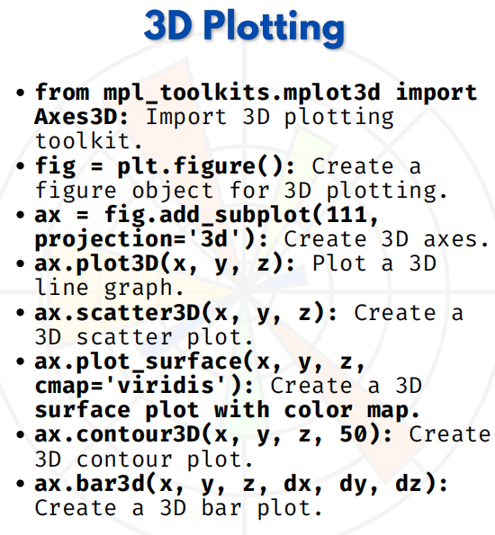

3D PLOTTING

1. Import 3D Toolkit
from mpl_toolkits.mplot3d import Axes3D

This imports the **3D plotting toolkit** in Matplotlib, which allows us to create 3D plots.
Example:
from mpl_toolkits.mplot3d import Axes3D
import matplotlib.pyplot as plt

2. Create a Figure
fig = plt.figure()
Creates a blank figure object that will hold our 3D plot.
Example:
fig = plt.figure()

3. Create 3D Axes
ax = fig.add_subplot(111, projection='3d')
Adds a 3D subplot (axes) to the figure where we can plot 3D data.

Example:
ax = fig.add_subplot(111, projection='3d')

4. Plot a 3D Line Graph
ax.plot3D(x, y, z)
Plots a **3D line graph** with points `(x, y, z)`.

Example:
import numpy as np
x = np.linspace(-5, 5, 100)
y = np.sin(x)
z = np.cos(x)
ax.plot3D(x, y, z, 'blue')
plt.show()

5. Create a 3D Scatter Plot
ax.scatter3D(x, y, z)
Creates a **3D scatter plot** to show individual data points.
Example:
x = np.random.rand(50)
y = np.random.rand(50)
z = np.random.rand(50)
ax.scatter3D(x, y, z, color='red')
plt.show()
6. Create a 3D Surface Plot
ax.plot_surface(x, y, z, cmap='viridis')
Plots a **3D surface** using a grid of x, y, z values with a color map.
Example:
X = np.linspace(-5, 5, 30)
Y = np.linspace(-5, 5, 30)
X, Y = np.meshgrid(X, Y)
Z = np.sin(np.sqrt(X**2 + Y**2))
ax.plot_surface(X, Y, Z, cmap='viridis')
plt.show()

7. Create a 3D Contour Plot**
ax.contour3D(x, y, z, 50)
Creates a **3D contour plot** with 50 contour levels.

Example:
X = np.linspace(-5, 5, 30)
Y = np.linspace(-5, 5, 30)
X, Y = np.meshgrid(X, Y)
Z = np.sin(np.sqrt(X**2 + Y**2))
ax.contour3D(X, Y, Z, 50, cmap='binary')
plt.show()

8. Create a 3D Bar Plot
ax.bar3d(x, y, z, dx, dy, dz)
Creates **3D bar charts** at positions `(x, y, z)` with bar dimensions (dx, dy, dz)

Example:
x = [1, 2, 3, 4, 5]
y = [2, 3, 4, 5, 6]
z = [0, 0, 0, 0, 0]
dx = dy = [0.5, 0.5, 0.5, 0.5, 0.5]
dz = [1, 2, 3, 4, 5]
ax.bar3d(x, y, z, dx, dy, dz, color='green')
plt.show()

